Chapter 4, Solution 4.

If I_{o} = 1, the voltage across the 6Ω resistor is 6V so that the current through the 3Ω resistor is 2A.
2 Ω
3 Ω
4 Ω
6 Ω
2A
I_{s}
1A
3A
(a)
i₁
2 Ω
4 Ω
2 Ω
I_{s}
3A
(b)
+
v₁
−

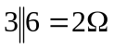, v_{o} = 3(4) = 12V, 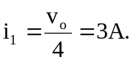
Hence I_{s} = 3 + 3 = 6A

If I_{s} = 6A I_{o} = 1
I_{s} = 9A I_{o} = 9/6 = 1.5A

